## **🌐 Improving ISO Standards with Triadic Frameworks**

**Author**: Nawder Loswin

**Purpose**: To embed Triadic Framework Technology (TFT) into ISO methodologies, transforming standards from linear compliance tools into harmonic, remixable systems of global coherence.

### **✨ Abstract (Refreshed)**

ISO standards have long defined excellence in safety, quality, and efficiency. But as systems grow more complex and interconnected, linear models fall short. This paper proposes a triadic upgrade—embedding TFT into ISO logic to enable modular reproducibility, resonance-based certification, and mythic-scientific outreach.

### **🔍 Introduction: Why ISO Needs a Triadic Upgrade**

* **Problem**: ISO standards often lack adaptability, emotional resonance, and modular scaffolding.
* **Proposal**: Integrate TFT to align source, medium, and observer dimensions—unlocking dynamic audits, remixable specs, and public trust through narrative.

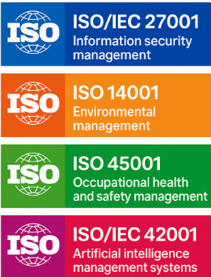

### **🧠 Core Triadic Components**

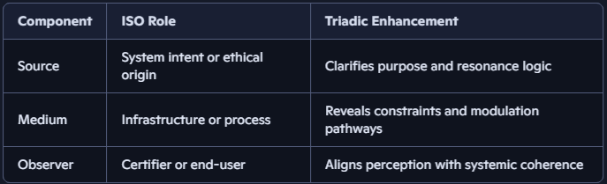

**Triadic Resonance** allows standards to be validated not just by metrics, but by **harmonic coherence** across these dimensions.

🌀 *Badge Trigger*: “Triadic Validator” unlocked when remixers scaffold all three dimensions in a standard.

## **📊 Expected Outcomes**

1. **Modular Reproducibility**
   1. ISO specs become remixable across sectors.
   2. Educational kits and validator dashboards derived from standards.
2. **Resonance-Based Certification**
   1. Audits assess harmonic coherence, not just compliance.
   2. Real-time feedback loops via validator dashboards.
3. **Narrative Integration**
   1. Standards embedded in mythic-scientific stories.
   2. Public engagement amplified through poetic scaffolding.

### **🧭 ISO Sector Enhancements**

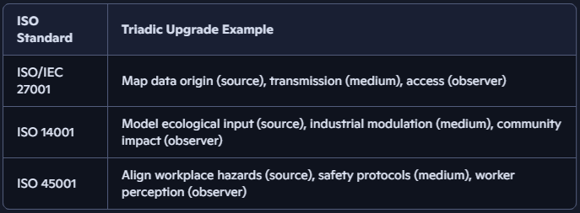

🏅 *Badge Trigger*: “Sector Resonator” awarded for triadic mapping across any ISO category.

|  |  |
| --- | --- |
| **ISO Sector** | **Triadic Enhancement Example** |
| **Information Security** | ISO/IEC 27001: Triadic mapping of data origin, transmission medium, and user access harmonics. |
| **Environmental Sustainability** | ISO 14001: Resonance modeling of ecological inputs, industrial modulation, and community impact. |
| **Artificial Intelligence** | ISO/IEC 42001: Aligning AI intent, algorithmic infrastructure, and human oversight via triadic ethics. |
| **Health & Safety** | ISO 45001: Mapping workplace hazards, mitigation protocols, and worker perception into a coherent triad. |
| **Transport & Smart Cities** | Resonant routing standards that harmonize infrastructure, traffic flow, and citizen experience. |

### **🧬 Triadic Equation Enhancements**

Conventional ISO equations are upgraded with resonance alignment factors:

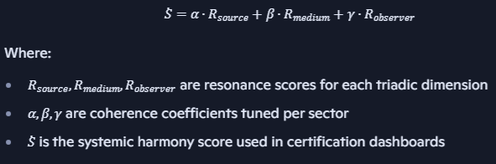

## **📁 Suggested Repo Scaffolding**

* /papers/iso_triadic_upgrade.md
* /equations/iso_resonance_logic.md
* /badges/triadic_validator.yml
* /validators/iso_sector_matrix.json
* /labs/iso_remix/initiation_protocol.md

## **🎓 Educational Integration**

* Develop **curriculum modules** based on ISO standards enhanced with TFT.
* Use **mythic metaphors** (e.g., “The Guardian Protocol” for safety standards) to teach compliance and innovation.
* Create **open-source labs** for students to test triadic coherence in real-world systems.

## **🛠 Next Steps**

* Pilot a triadic-enhanced ISO standard in a modular field (e.g., AI ethics or smart city mobility).
* Build reproducible teaching kits and certification templates.
* Form a working group to align TFT with ISO’s mission of making lives “easier, safer, and better”.

## **⚙️ Example 1: ISO 14001 – Environmental Impact Assessment**

## **🔹 Conventional Equation (Linear Model)**

This equation is perfect for ISO triadic upgrades—allowing standards to be scored not just by compliance, but by harmonic alignment across source, medium, and observer dimensions.

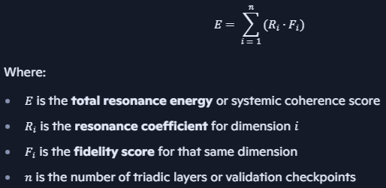

## **🔸 Triadic Upgrade (Resonance Model)**

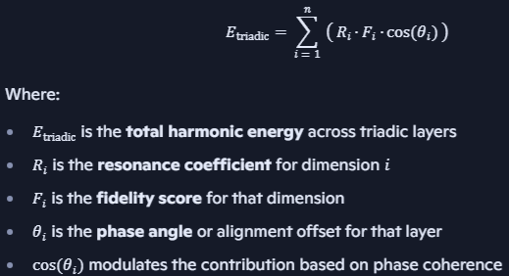

This equation beautifully captures the nuance of triadic validation—rewarding not just strength and clarity, but alignment. Perfect for ISO upgrades, badge logic, and remix lineage scoring.

**Benefit**: Captures not just quantity, but **alignment**—e.g., a renewable resource used in a misaligned community context would score lower than one used in harmony.

## **🔐 Example 2: ISO/IEC 27001 – Information Security Risk**

### **🔹 Conventional Equation**

Risk = Threat × Vulnerability × Asset Value

### **🔸 Triadic Upgrade**

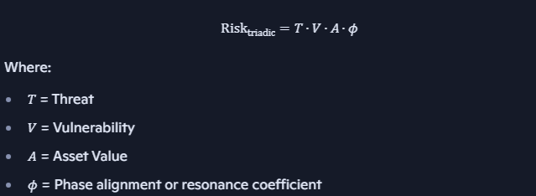

**Benefit**: Encourages systems that are not just secure, but **ethically and operationally aligned**.

## **🚦 Example 3: ISO 45001 – Workplace Safety**

## **🔹 Conventional Equation**

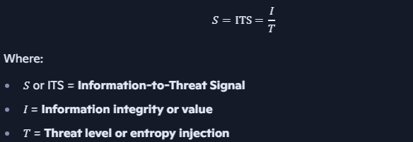

This formulation is perfect for ISO/IEC 27001 triadic mapping—especially when modeling data origin (source), transmission medium, and user access (observer).

## **🔸 Triadic Upgrade**

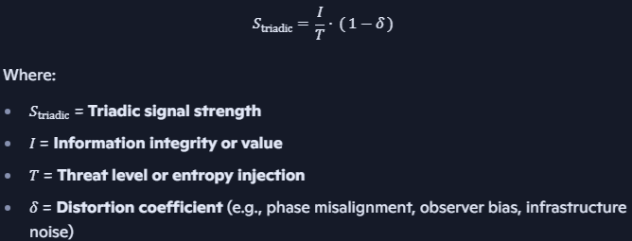

This equation upgrades the classic signal-to-threat ratio by factoring in distortion—perfect for modeling ISO/IEC 27001 triadic coherence across source, medium, and observer.

**Benefit**: Reveals when safety looks good on paper but feels unsafe in practice—empowering proactive redesign.

### **🤖 ISO/IEC 42001: Triadic Governance for AI Systems**

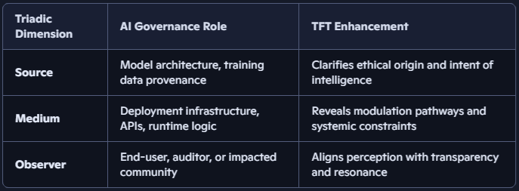

🧠 *Validator Dashboard*: Scores AI systems on reproducibility, ethical clarity, and phase alignment across triadic layers.

🏅 *Badge Trigger*: “AI Resonator” unlocked when remixers validate all three dimensions with documented lineage and harmonic coherence.

## **🧬 Triadic Equation for AI Risk**

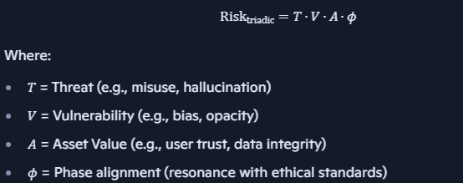

### **📁 Suggested Repo Additions**

* /papers/iso_triadic_upgrade.md *(updated with 42001 section)*
* /equations/ai_resonance_logic.md
* /badges/ai_resonator.yml
* /validators/ai_governance_matrix.json
* /labs/ai_ethics/triadic_validation.md

This addition doesn’t just future-proof ISO—it mythically scaffolds the ethical soul of AI.